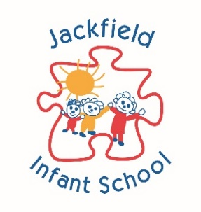
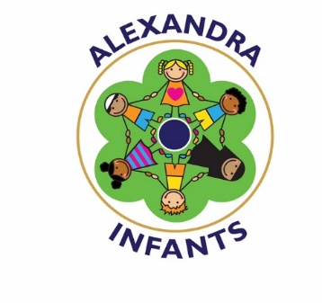
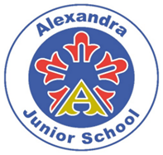

Photographic Images Consent Form
POLICY

This policy has been adopted on behalf of all academy schools in The New Guild Trust:

Moorpark Junior School
Jackfield Infant School
Alexandra Junior School
Alexandra Infants’ School

Approval and Review

Committee to Approve Policy | Trust Board
Date of Trustee Board / Academy Committee Approval | December 2022
Chair of Trustee Board / Academy Committee | Mrs L Eagle
Signature | L. Eagle
Accounting Officer | Mrs K Peters
Signature | K. Peters
Policy Review Period | 12 months
Date of Policy Review | December 2023

Version Control

Version | Date Approved | Changes | Reason for Alterations
Initial | Dec 2021
 | Dec 2022 | No changes

Photographic Images Consent Form

Pupil Images

Occasionally, we may take photographs of the children at our school. We use these images as part of our school displays and sometimes in other printed publications. We will also use them on our school website, Facebook page and Twitter account.

If we use photographs of individual pupils, we will not use the name of that child in the accompanying text or photo caption. If we name a pupil in the text, we will not use a photograph of that child to accompany the article. If a child has won an award and the parent would like the name of their child to accompany their picture we will obtain permission from the parent before using the image.

From time to time, our school may be visited by the media who will take photographs or film footage of a high profile event. Children may appear in these images, which will sometimes be published in local or national newspapers, or on approved websites.

Please use the boxes below to indicate () whether you give consent to each medium:

 | Yes | No
I give permission for my child’s photo to be used within school for display purposes.
I give permission for my child’s photo to be used in Learning Journeys
I give permission for my child’s photo to be used on the school website
I give permission for my child’s photo to be used in other printed publications
I give permission for my child’s photo to be used on the school’s social media sites
I give permission for my child’s photo to be used on the school’s community websites (e.g. Dojo)
I give permission for my child to appear in the media
I give permission for my child to have a school photograph taken.
I understand this printed/digital photograph can be purchased by parents.

Marketing & Fundraising

We would like to be able to inform you about school based events (such as open mornings, fundraising events, class assemblies) either by phone, text, emails or letters.

Please use the boxes below to indicate () how you agree for the school to contact you for these purposes (more than one box can be ticked if you consent for more than one medium of communication):

Telephone Call |  | Email |  | None of The Above
Text Message |  | Letter

This form is valid for the current academic year. Parental consent for these areas will be requested on an annual basis to ensure that consent is still valid.

Consent to any of the above can be withdrawn by parents. Please provide the school with written confirmation that you withdraw your consent and specify which area(s) this is in relation to.

Parent/Carer Signature: |  | Date:
Print Name: |  | Relationship to Child:
Child’s Name:

