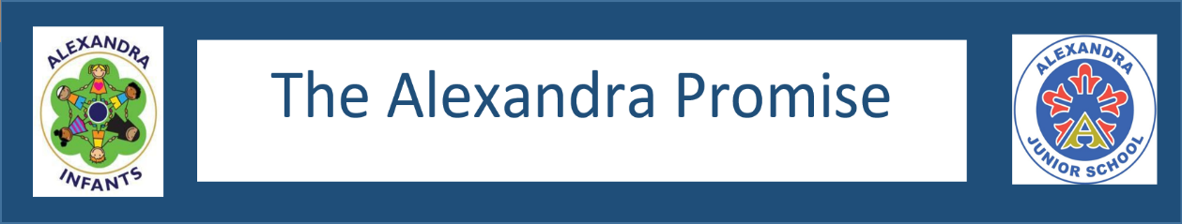

My Activity Passport

Year 6

Activity
 |  |  |  |  | Date:
1. | Keep a diary for a week
2. | See the sun set.
3. | Put on a performance
4. | Write a speech
5. | Take part in a bird watch
6. | Interview someone
7. | Visit a local charity and find out how you can support them
8. | Make something with wood
9. | Design a product or business idea and pitch it to ‘investors’
10. | Challenge yourself and try something new
11. | Visit a new place of worship
12. | Make a healthy snack
13. | Write and post a letter
14. | Make a pinhole camera
15. | Visit the Council Chambers
16. | Make a film
17. | Try yoga
18. | Stay away for the night

The Alexandra Promise

Growing up – it is about finding out who you are by figuring out what is out there and how to fit in with the world around you before you can make your move, the move that makes you stand out and that leaves your mark forever. Many roads have to be travelled and many encounters made along the way before you reach your destiny. Many hours have to be spent in preparation to hone your skills and shape your mind. That’s what education is all about: from being lead and guided on your path through life to becoming independent and to becoming yourself.
All the experiences, the opportunities for exploration, self-expression, engagement with others entailed in your promise are designed to help you to get to know yourself and embrace who you are so that you can choose how to be awesome, to excel, to stand out.



Reception

Activity
 |  |  |  |  | Date:
1. | Visit a farm
 | Paint a self portrait
2. | Paint a self portrait
 | Go on an autumn walk and make leaf rubbings
3. | Plant some bulbs and watch them grow
 | Go on an autumn walk and make leaf rubbings
4. | Go on an autumn walk and make leaf rubbings
 | Visit a place of worship
5. | Make a sandwich
 | Go on an autumn walk and make leaf rubbings
6. | Visit a place of worship
 | Hunt for a minibeast
7. | Fly a kite
 | Dress up like a pirate and make a treasure map
8. | Make a paper boat and see if it floats
9. | Perform a song
10. | Re-tell a story to an audience
11. | Post a letter
12. | Hunt for a minibeast
13. | Take a photograph
14. | Dress up like a pirate and make a treasure map
 | Make a paper boat and see if it floats
15. | Look up where you live on a map
16. | Have a teddy bears picnic and taste new fruit
17. | Visit a library
18. | Play in the snow
19. | Hatch a chick
20. | Dress up as a super hero

Year 5

Activity
 |  |  |  |  | Date:
1. | Take part in a debate
2. | Learn something new about your local area
3. | Learn to moon walk
4. | Make and launch an air powered rocket
5. | Use an OS map and a compass
6. | Learn how to access the news
7. | Do a blindfold taste test
8. | Fly a kite
9. | Use a telescope
10. | Eat pizza with my friends
11. | Learn to swim
12. | Climb something that is taller than you
13. | Pick litter in your local area
14. | Take part in pond dipping
15. | Help the environment
16. | Learn to ride a bike
17. | Make chocolate
18. | Make a sculpture

Year 4

Activity
 |  |  |  |  | Date:
1. | Make a music instrument
2. | Write and perform a poem
3. | Perform in a front of an audience
4. | Watch a play or dance production
5. | Use a camera to document a performance
6. | Choreograph a dance
7. | Walk through a forest
8. | Learn about a new religion
9. | Paddle in a river
10. | Make up your own game and teach it to someone
11. | Go on a sound walk
12. | Visit a castle
13. | Learn to sew on a button
14. | Skim stones
15. | Take part in a treasure hunt
16. | Plan and make a dessert
17. | Eat like a Roman
18. | Create a mosaic

Year 1

Activity
 |  |  |  |  | Date:
1. | Record different sounds and ask others to guess what they are
2. | Make some biscuits
3. | Make and taste chapatis
4. | Make a puppet
5. | Put on a puppet show
6. | Borrow a book from a library
7. | Discover what is in a pond
8. | Create a piece of art for an exhibition
9. | Visit a museum
10. | Perform a dance
11. | Create a class collage
12. | Create a comic strip
13. | Take part in a play day
14. | Roll down a hill
15. | Make a daisy chain
16. | Join an extra-curricular club
17. | Build a den
18. | Perform in front of your class
19. | Write a weather report for your class
20. | Walk to a local landmark

Year 2

Activity
 |  |  |  |  | Date:
1. | Plan a party
2. | Play a board game
3. | Learn a poem off by heart
4. | Take a trip to the seaside or walk alongside a river
5. | Bake a cake
6. | Buy something and check your change
7. | Become a nature detective
8. | Start a vegetable patch – plant, test, grow
9. | Pick blackberries
10. | Get soaking wet in the rain
11. | Go bird watching
12. | Learn a French song
13. | Walk barefoot on the sand or a nature trail
14. | Start a collection and share it with your class
15. | Make a mask
16. | Play pooh sticks
17. | Climb up a huge hill
18. | Catch a falling leaf
19. | Go on a hunt for some insects or small creatures
20. | Make a home for an insect or small creature

Year 3

Activity
 |  |  |  |  | Date:
1. | Compose a piece of music
2. | Eat something you’ve not tried before
3. | Design and make a board game
4. | Climb a tree
5. | Light a candle
6. | Learn a new game
7. | Lie down and look at cloud patterns
8. | Tell your class about your favourite character from a book
9. | Grown your own food
10. | Eat something you have grown
11. | Write in hieroglyphics
12. | Produce rubbings of fossils
13. | Vote in a school election
14. | Go on a picnic
15. | Make a volcano
16. | Create a display for show and tell
17. | Read to a rabbit
18. | Visit the countryside

